CHAPTER 4: Ecosystems
Worksheet 4.7

Population overload
Science Quest 7: pages 163–165
Student: Class:
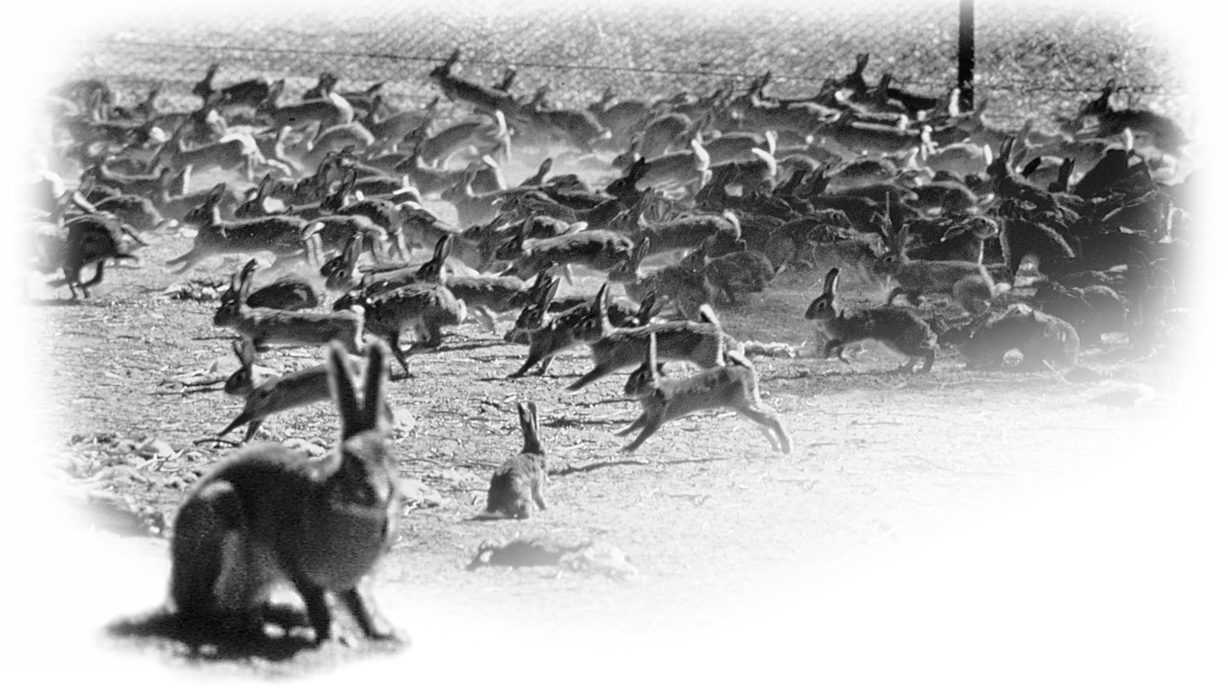
The European rabbit arrived in Australia with the First Fleet in 1788. In less than a hundred years, it had increased to plague proportions. The damage caused by the rabbit is estimated to cost the farming industry over $600 million per year. The success of the rabbit is due to a number of factors. First, with land cleared for farms there is an abundance of food provided by grazing pastures. Second, a female rabbit can produce four to six kittens every month. Third, rabbits are able to travel long distances to find food and can tolerate drier conditions than many other animals.

A rabbit investigation
A breeding pair of rabbits was introduced onto a small island off the coast of New South Wales. Population numbers were collected each year. The data in the table on the right show the number of rabbits over twelve years. After five years, it was realised that the rabbits were causing erosion problems for the land and so two cats, natural predators of rabbits, were introduced. Their numbers are also shown.
● In the box on the next page, draw a line graph of the rabbit population over the twelve years. Place the number of rabbits on the left-hand vertical axis and the year on the horizontal axis. Extend the horizontal axis up to the year 2012.
Year | Number of rabbits | Number of cats
1984 | 2 | –
1985 | 17 | –
1986 | 59 | –
1987 | 190 | –
1988 | 470 | –
1989 | 980 | –
1990 | 830 | 2
1991 | 560 | 6
1992 | 210 | 14
1993 | 80 | 9
1994 | 140 | 6
1995 | 100 | 8
1996 | 130 | 6

CHAPTER 4: Ecosystems PAGE 2
Worksheet 4.7

● On the same graph, add a vertical axis on the right-hand side. (The right-hand axis does not need the same scale as the left-hand axis.)
● Using the right-hand axis, draw a line graph to represent the number of cats.

Discussion
1. What effect did the cats have on the size of the rabbit population from 1989 to 1993?

2. Why do you think the cat population stopped increasing in 1993?

3. Describe what seems to be happening to the two populations from 1993 on. (Hint: Look at the shape of your graphs.)

4. Predict population numbers for the rabbits and cats on the island up to the year 2012. Plot your predictions on the graph. Compare your graph with that of a partner.
5. What do you think would have happened to rabbit numbers if the cats weren’t introduced to the island? Explain your answer.

6. Introducing cats to the island could cause problems too. Explain why.

